Reza Moazami convicted of human trafficking in teen prostitution case

B.C. Supreme Court judge convicts Vancouver man on 30 charges, including human trafficking
CBC News Posted: Sep 15, 2014 10:37 AM PT Last Updated: Sep 15, 2014 4:34 PM PT
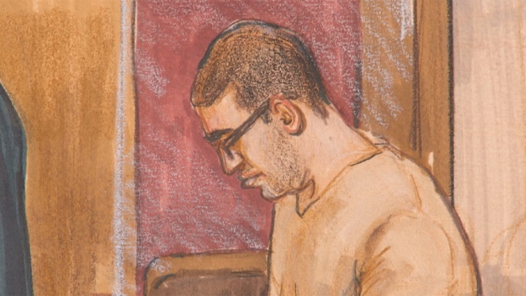
Reza Moazami, 29, was convicted on 30 charges linked to the prostitution of teenaged girls, on Monday in B.C. Supreme Court. (CBC)
A Vancouver man charged with luring 11 teenagers into prostitution, using sexual assaults and drugs to control them, has been convicted on 30 counts including one of human trafficking, in B.C. Supreme Court.
Reza Moazami, 29, was convicted Monday of convincing the teenage girls to have sex for money between February 2009 and October 2011, when he was arrested.
The case marks B.C.'s first human trafficking conviction under the Criminal Code.
The court heard Moazami promised his victims, some as young as 14, a glamorous life of drugs and booze in downtown Vancouver,
Justice Catherine Bruce, who heard the case without a jury, heard that the girls made tens of thousands of dollars for Moazami.
While some were given part of their earnings and had their freedom, others received no compensation and could not leave the south Vancouver house, where Moazami set up operations, without his permission.
Crown counsel cited text messages from cell phones and Facebook messages between Moazami and the complainants as evidence. Some of complainants were already working as prostitutes when they met Moazami, while others fell into it after meeting him, the court heard.
Vancouver police Sgt. Richard Akin told reporters it took three years to investigate, arrest and get Moazami convicted in the complex case. He said the 11 young women working for Moazami are the most ever seen in a Vancouver prostitution case.
"I would be surprised if anyone had a larger victim pool for a court case in the country," Akin said outside of court after the conviction.
"We made it a priority under our guidelines that we will investigate, deter and prevent juvenile females from entering the sex trade," he added.
Crown counsel Kristin Bryson commended the victims for coming forward to tell their stories.
"It was very difficult for all of them to do that. It's not easy to discuss the personal details of your life and they did it. Just getting the case before the courts was very significant," Bryson told reporters.
Moazami was charged with 36 charges including human trafficking, living on the avails of a juvenile, sexual assault and sexual interference.
He was convicted on one of the two human trafficking charges and found not guilty on the second one after one of the young women recanted earlier evidence on the witness stand.
On Monday morning Justice Bruce concluded in her reasons for judgment that Moazami was not a credible witness.
Sentencing is set for Dec. 9. Some of the convictions bring a minimum of five years in prison.
With files from Jason Proctor

